Structures
Reference the image below for Questions 1–6.
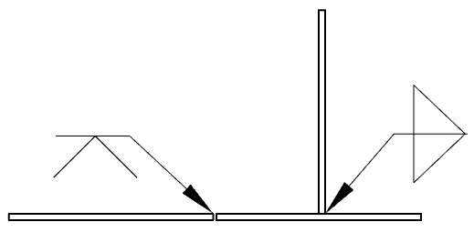

- What type of joint is shown in the first weld (left side)?
  - Butt joint
  - Corner joint
  - T-joint
  - Lap joint
- What type of weld is shown in the first weld (left side)?
  - Groove weld
  - Plug weld
  - Edge weld
  - Fillet weld
- Which best describes the placement of welds in the first weld (left side)?
  - Top only
  - Bottom only
  - Both sides
  - All of the above
- What type of joint is shown in the second weld (right side)?
  - Butt joint
  - Corner joint
  - T-joint
  - Lap joint
- What type of weld is shown in the second weld (right side)?
  - Groove weld
  - Plug weld
  - Edge weld
  - Fillet weld
- Which best describes the placement of welds in the second weld (right-side)?
  - Top only
  - Bottom only
  - Both sides
  - All of the above

- Excessive spatter during welding is most often caused by:
  - Too low amperage
  - Too high amperage
  - Improper shielding gas
  - Moving too slowly
- Which gas is commonly used as a shielding gas in GMAW welding?
  - Oxygen
  - Carbon dioxide
  - Argon
  - Nitrogen
Compact Equipment
- What is the purpose of the choke in a small gas engine during startup?
  - Increase airflow for better combustion
  - Increase the fuel-to-air ratio
  - Reduce engine compression
  - Advance ignition timing
- An engine is backfiring through the carburetor. What is the most likely cause?
  - Low oil level in the crankcase
  - The fuel mixture is too lean
  - Spark plug gap is too wide
  - Intake valve gap or timing
- What is the function of the crankshaft in a small gas engine?
  - To open and close the valves in time with engine stages
  - Push out the exhaust to ensure the engine does not overheat
  - Convert reciprocating motion into rotational motion
  - To regulate fuel delivery
- What is the function of the camshaft in a small gas engine?
  - To open and close the valves in time with engine stages
  - Push out the exhaust to ensure the engine does not overheat
  - Convert reciprocating motion into rotational motion
  - To regulate fuel delivery
- Which stroke of a 4-stroke engine cycle occurs after the spark plug ignites?
  - Intake stroke
  - Compression stroke
  - Power stroke
  - Exhaust stroke
Machinery and Equipment
- In a round baler, what is the purpose of the belts or rollers inside the bale chamber?
  - Lift crop from the ground into baler
  - Rotate crop into a dense bale
  - Secure crop and fasten with a wrap
  - Eject the bale
- A farm employee is performing routine preventative maintenance on a round baler and notices several Zerk fittings around moving joints. What is the best preventative maintenance practice?
  - Apply grease only if the joint is squeaking
  - Remove the Zerk fittings and clean them before reinstallation
  - Grease each fitting according to the OEM’s recommended schedule
  - Fill the fittings until grease leaks out
- What is the main purpose of proper chain tension in a sprocket and chain system?
  - Prevent slipping and wear
  - Reduce lubrication needs
  - Eliminate the need for sprockets
  - All of the above
Electrical
Reference the image below for Questions 17–18.
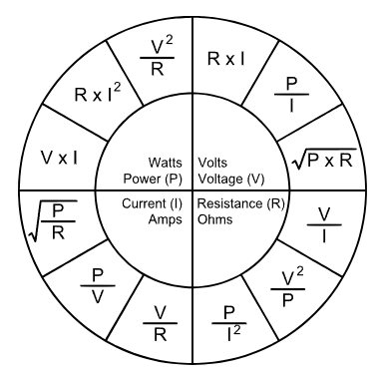
- What is the power output of a 12V system that draws 5 amps of current?
  - 0.42 watts
  - 2.4 watts
  - 12 watts
  - 60 watts
- In a 12V electrical system, a circuit draws 3 amps of current. What is the resistance of the circuit?
  - 0.25Ω
  - 4Ω
  - 36Ω
  - 64Ω
- What unit is used to measure electrical force?
  - Ampere
  - Ohm
  - Volt
  - Watt
- Which type of electrical circuit has one path for current to flow?
  - Series circuit
  - Parallel circuit
  - Complex circuit
  - Combination circuit
- A tractor runs on a 12V system. When the tractor is running, you measure 14V at the battery terminal. What does this describe?
  - The alternator is overcharging the battery, and the battery will fail
  - The battery is overloaded
  - The alternator is charging the battery as designed
  - The diode in the alternator is not stabilizing the charge
Natural Resources
- A best management practice (BMP) for reducing nutrient runoff includes:
  - Overapplying fertilizer
  - Planting cover crops
  - Burning crop residues
  - Diluting herbicides with water
- How many acres are in one section of land?
  - 160 acres
  - 320 acres
  - 640 acres
  - 1,280 acres
- A field is described as the S 1/2 of the NE 1/4 of a section. How many acres does this area contain?
  - 40 acres
  - 80 acres
  - 120 acres
  - 160 acres
- Which statement describing the difference between GNSS and RTK in precision agriculture is incorrect?
  - GNSS uses multiple satellites
  - RTK replaces satellites with ground signals
  - RTK improves positional accuracy
  - RTK is more accurate than GNSS alone

